Avatar Tutorial for Games (Neverwinter Nights in particular)

Here is a short illustrated 'tutorial' that walks through how I created a female elf portrait. I personally like to use PSP for doing gaming pictures, as it tends to lend a ‘fantasy’ feel to the image as well as being nice to give the image a good painted feeling. I also have both Adobe Photoshop and Dreamweaver’s Fireworks (I tend to use all three when working on an image, as there are things that you can do with each of the three programs that are not found in the others). Or, in other words, I like to crash out my computer…a lot.

The other thing you will need is a good source photo. Yes, these are of course all paint-overs of original pictures. I hope you will see that they are thorough paint-overs, and work goes into adapting them quite radically from the original image. Even the great Boris Vallejo traces over photos to get that photorealistic fantasy look. The photo should be high resolution - too high, preferably desktop sized - and have good contrast. You can work with the picture quality, but you cannot pluck detail out of nowhere, so nothing too fuzzy or too dark.

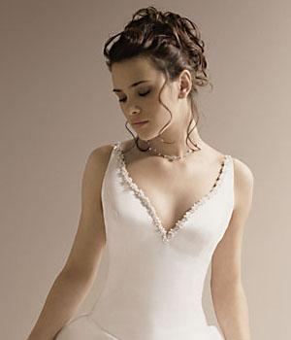
This is an original photograph of my sister in one of her prom dresses. The background is nice, but that will be the first thing you lose, so backgrounds do not matter. The main problem with this image is it is a bit flat and one-colored - an issue I would have to work with later.

Of course, the source of the original image should be credited wherever possible, and avoid obviously protected material. I have used copyright-free images and my own photos to create my portraits, but I have also found some source pictures on the net. I would not suggest using anything that has already been carefully worked on - e.g., other people's artwork. If it is on the net, it is fair game, I think, though always check the text on the site - prominent reminders that you are looking at copyright material suggest a litigious owner. I am not clear what the law is on this... but since you will not be making any money, and you will be changing the images quite thoroughly, a reference and a link shows politeness.

Tip #1 Choose an interesting face, someone unusual. It is tempting always to go for pretty girls (if you are a guy) but character clearly counts! I would avoid well-known faces, too.

Ok, so the first thing that you have to do is change out the background. Most tutorials will tell you to go ahead and resize the image down to whatever dimensions you are allowed to have in the game but I like working with the larger images. It is a heck of a lot easier to see that way.

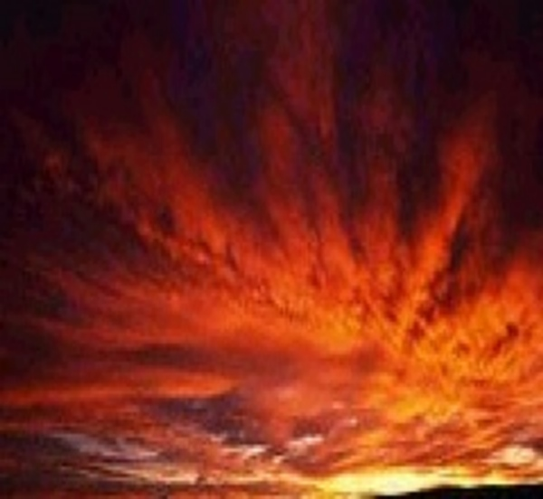

So, what you want to do to change out the background is to pick an interesting background to transport your picture to. After you have picked your image, what you want to do is use the lasso tool and cut out the girl in the first image. Paste her as a new layer onto the new background. The reason that you want to treat her as a new layer is so that you can use the eraser tool to clean up the edges around where you cut out the original picture. It also allows you the freedom to move the girl around on the background at any point before you save.

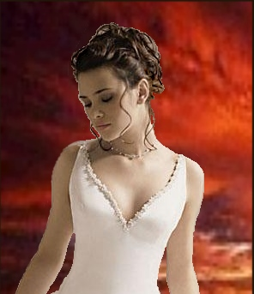

At this point, all I have done is take her from one photograph to the other. I did a little bit of darkening work on her hair, just because that fine a cut out is hard to make but all I did was bump the brightness and contrast down to blend better.

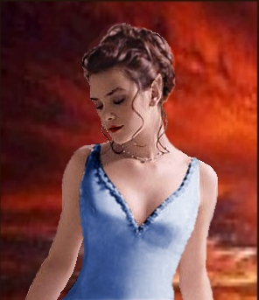

A lot of work has been done at this stage. Using the retouch tool, I pulled her ear into elf shape, deepened the eyebrow for a more dramatic effect, and tweaked the color and the shape of her lips. I tweaked the color of the entire photo by pushing the red up using the hue/saturation/lightness as well as darkening slightly and pumping up the saturation. This gives the picture a more blended feeling. I also changed the color of the dress using the lasso tool to select and then using first the Manual Color Correction in the Enhance Photo menu along side the colorize and adjust brightness and contrast. Once I had the dress the color I wanted it, I used the retouch tool again to clean up the edges and, finally, I softened all over the dress as well as all the places where I used the retouch tool. I always use soften after changing the color or using the retouch tool as it give the whole image more of a painted feeling to it. However, I would strongly suggest using the soften key in very localized areas as it tends to “wash out” images. Finally, I tweaked the color of her hair to a more reddish tint and softened it to blend the colors better.

Tip #2 This is stage one. Do not leave a portrait at this stage! Part of the knack of any art is knowing when you are finished. My rule of thumb is when it stops looking like a photo and starts looking like a Bioware portrait, it is just about there. Try bringing in a favorite NWN portrait to sit alongside it - do they 'go together'? After working on a picture for a while, you might want to just leave the room, have a cup of tea, and look at it again with fresh eyes.

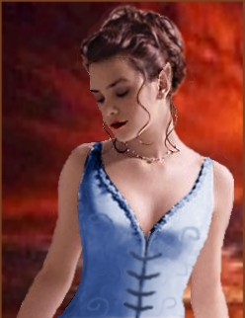

As you can see the first thing I did in this part was take the neckline and tug it down so that it looks like the dress is split. Once I did that, I pulled the slit out on either side in order to give the dress the appearance of laces. By the way, I do most of my work at 200% zoom, and 300% for the fine stuff like this. All of these modifications were done with retouching and softening...no real trick to it.
Tip #3 Take your portrait 'away' from the original picture. Tweak everything. Be radical with the background and the colors. The opposite of the previous tip: bring in a copy of the original. If they look pretty similar, work your portrait more.
Tip #4 Accessories and clothing are crucial. A valid criticism I have had is that the clothes are too modern - you need to include something that says 'this is a fantasy picture'. A tattoo, the shape of a cloak, removing modern-looking buttons or straps, or just choosing a picture with costume in mind - all these can help. These finishing touches are the tricky part, but they make all the difference.

The embroidered/silky effects on her dress are a cinch using a retouch and soften - it looks detailed but is easy to do and gives the image a bit more pop. The hardest part about doing that was actually making sure that the patterns went with the body under the dress...that just takes practice to get it right.

After that, I worked on all the pixilated edges a small piece at a time, softening all the hard spots. The reason I work like that, doing it a tiny bit at a time, is, for some reason, when you tell PSP7 to soften a large area, it gets really aggressive with the softening. it looks like a watercolor that someone spilled water on. The program is much better at doing small and localized softens...it gives the picture a painted feel but not a 'we spilled water all over it' feel. I also cropped the image down a bit; to get rid of some of the excess as well as remove some of the yellow that was starting to get on my nerves.

Tip #5 Save as you go! Especially before starting something bold like changing the clothing or adding an accessory. With the safety net of differently named saves, you can take bigger risks, and if you screw up, just go back. You will also end up with a sequence of images you could, say, make a tutorial with.

Now, you can leave the image like this or you can keep on going. On this one, I would be tempted to stop here but I want to change the lighting around a bit to make the image blend a bit better. PSP has a decent enough lighting selection but I personally think that both Adobe Photoshop and Dreamweaver’s Fireworks do a better job of rendering good lighting. Mostly what you want to do when you add lighting is just play around with it and see what works best for the photograph itself. I also want to add a border and some text on this one. Of course, neither one of those things are very hard to do as PSP’s tool for that are both easy to use and simple to understand.

And here is the finished product...I added a border and put her name on it...
Depending on the game, you will have to resize the image and save it to the game’s format but most games will walk you through it.
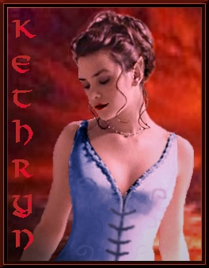
And there you have it! One completed NWN portrait. This needs to be saved in Paint Shop Pro as an uncompressed, 24-bit Truevison Targa (.tga) with dimensions 256x512 pixels. The image itself should be 256x400, and the extra added at the bottom of the picture using Paint Shop's 'canvas size' function. You can download a free trial of PSP from Jasc software's website. You'll need to reduce the size by 50% four more times, saving as you go in the same format, and naming the portraits so they end with H, L, M, S and T in descending order of size. Then pop the picture in your NWN/Portraits folder, make a new character, and you are away!

